

**Intelligent Manhole Cover system 1.0**

report



2021-5-2

Chen Jinyi 1063692

Li Guanchi 1063864

Wang Yilun 1064067

Wei Zhangyu 1064082

Zhang Ye 1064211

Contents

1 1. Introduction: 2

1.1 1.1 Purpose 2

1.2 1.2 Project Overview 2

2 2. Evaluation 2

3 3. TEST Environment 3

4 4. TEST Method 4

4.1 4.1 Unimplemented functionality 4

4.2 4.2 Problems from testing 4

5 5. Current and potential deficiency 5

5.1 5.1 deficiency describing: 5

6 6. Solution 5

6.1 6.1 Solution 5

6.2 6. 2 Review the Test 5

# 1. Introduction:

## 1.1 Purpose

This is the test report of intelligent manhole cover system version 1.0. Our team will analyze the current integrity of the project and show the number of defects and bugs.

## 1.2 Project Overview

Well cover is an important part of urban drainage system, which connects sewer and ground. In the past few years, people's property losses caused by the loss or damage of manhole covers or buildings are common. The loss or damage of manhole covers often poses a great threat to public safety. The goal of the project is to create an intelligent manhole cover based on Arduino microcontroller and various sensors, which has various functions and relates to big data platform. It can realize real-time monitoring of environmental temperature, humidity and other data, display whether the well cover is missing or offset on the big data platform and monitor whether the sewer is blocked. The application allows users to:

* The position of the manhole cover is accurately located by GPS module.
* When the intelligent manhole cover is damaged or lost, it can receive the alarm message from the intelligent manhole cover.
* Be able to view the data collected by the smart manhole cover on Android operating system.
* The ground temperature, humidity and rainfall detected by sensors are monitored through the data platform.

# 2. Evaluation

In this chapter, we will make a summary of the previous work of the group. In the final version 1.0, the previous team completed almost all the functions they planned. For the measurement of water temperature and humidity in the well, the measurement of water level in the well, and the positioning of the well cover. They have also made an app that can display all information. This app is based on IOT studio of Ali-cloud, and the database is also based on the management system built by Ali-cloud server.

First, the data of this project is responsible for recording water temperature, humidity, water level height, and well cover position. Each kind of data can be extracted or combined to use and view separately. The data management of the whole database is very strict, but the data stream cannot be stably transmitted to the database is a huge problem. The instability of the whole program will be reduced if the data cannot be obtained stably.

Secondly, the location data of this project is recorded and processed based on Gaode map, and then converted into historical address data. These data are visualized in the form of maps on the official website of the project, but this goal has not been achieved on the mobile phone. And because of the four-corner positioning method, the position of the manhole cover should be in any area of the four points, but the processing result is shown as the center point of the area composed of the four points.

Finally, there are some simple explanations of the app. Although the interface of the app is simple, it is less beautiful at the same time. The interface of the app is divided into three parts: temperature, humidity and water level record. This app is very effective in data visualization. Different colors are used to represent different colors in water level measurement. For example, the dangerous water level is red, which can be changed and added later. In general, the app has strong functionality, can well show the required data and is easy to understand, but I think the app can make some improvements in user interaction, such as interactive manhole cover location and number search.

# 3. TEST Environment

Testing Environment

For the testing of this project, we decided to divide it into three parts, the first part is to test the functionality of the manhole cover, the second part is to test the functionality of the cell phone and web side, and the third part is to test the database.

Well cover part: We placed the well cover in a set experimental environment, which included a specified amount of water level and temperature. After the experiment started, we kept changing the water level and temperature to see if the well cover was monitoring the data and transmitting it properly, to confirm whether the data from the well cover could be correctly connected to the server, and to see if the well cover could stand in wet, dry, cold, and high temperature environments to operate properly.

Cell phone & Web part: First test the network connection and data transmission to confirm whether the data of the manhole cover can be received and displayed normally. At the same time, we used different models of Android phones (Samsung and Huawei were chosen for this test) to observe whether the UI was suitable and used Edge and Chrome under Windows and Apple's Safari for the Web part to observe whether the web pages could be displayed normally.

Database part: The database test is mainly about data transmission and storage, here we must place manhole covers at different locations to observe whether the positioning information is accurate. The login system of the database should also be tested to confirm whether users can log in normally. It is also necessary to ensure that the database can store data online 24 hours a day without disconnection. Finally, it is important to check whether the data receiving and sending of the database is normal.

# 4. TEST Method

## 4.1 Unimplemented functionality

In SRS, when the smart manhole cover is damaged or lost, the user can receive the alarm message from the smart manhole cover. This function has not been implemented yet.

## 4.2 Problems from testing

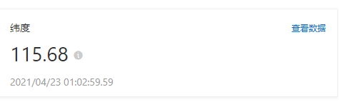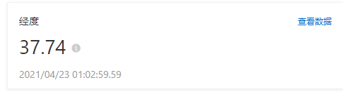

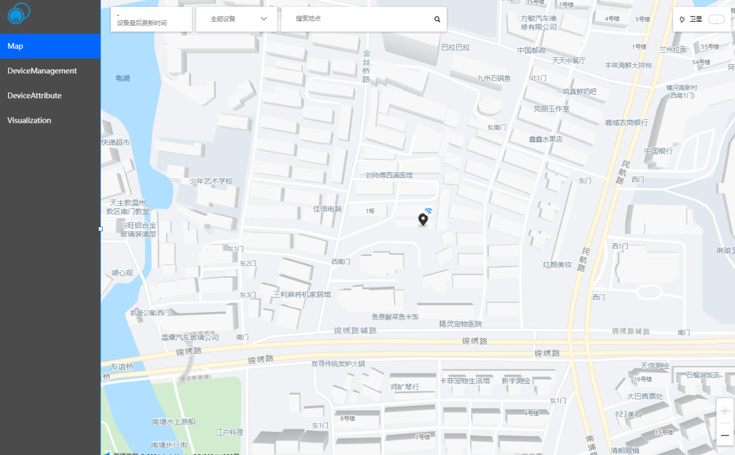

* This is the current GPS positioning of the project. This can only display the current position of the intelligent manhole cover. If the manhole cover is in the correct position, it can not be displayed at all, only when it is not in the true position. In addition, GPS can only ensure a range or area, so it is not dynamic. This needs to be improved.
* Now we can log in to the application with a special account. However, the login page cannot connect to the database, so we need to register in this application first.

# 5. Current and potential deficiency

## 5.1 deficiency describing:

* Occasionally false detection information is executed outside the water level sensor. There are often errors in the detection of water level.
* Unable to test the Internet related functionality of the application. Because the project has not been completely completed, it is impossible to test the success rate of the application and its connection with the Internet of things platform, as well as the possible problems.

**5.2 potential deficiency**

* The GPS module may fall off. When the manhole cover has left its original position, the GPS may fall off or be demolished and left in place.
* It is impossible to determine whether the well cover is damaged.

# 6. Solution

## 6.1 Solution

* For the problem of Positioning, the GPS can just ensure a scope or area, so it is not dynamic. Therefore, we can use GWT and Google Maps API to launch a browser-based map tool to set the GPS location in the simulator.
* The alarm function is not implemented. The function will be implemented after the GPS positioning function is implemented.
* User interface should be promoted, the precise coordinate will be show on the interface.
* The system should add an interface, the interface should show the “No.#” of each well cover, before interface of the data information of sensors, because there are not just one well cover. The administrator can search each well cover.
* Now we can login the app with a special account. However, login Page cannot connect the database, so we need register in this APP firstly. Therefore, in the next step, we need to connect the login page with database, then achieving register function.

## 6. 2 Review the Test

After testing, the product functions are easy to understand and use, consistent with the expected results, and basically realize the main functions of the product. The sensor data has been fully capable of realizing dynamic transmission and displayed on the APP interface. No special test methods were used during the test.

In future product development, we will continue to improve products based on product needs.